

3.7: Functions in Python Worksheet (Question 2) Walkthrough

So, the first thing we need to do is construct the pseudocode for the question:

OUTPUT enter words to be made into acronym

INPUT words entered by user

ASSIGN to variable (acronym_string)

SPLIT sentence into separate words

ACCESS first letter of first word

ASSIGN to variable (first_letter)

ACCESS first letter of second word

ASSIGN to variable (second_letter)

ACCESS first letter of third word

ASSIGN to variable (third_letter)

CONCATENATE three letters

ASSIGN to variable (acronym)

OUTPUT acronym

We can now use this pseudocode to produce functioning code:

| **Pseudocode** | **Functioning Code** |
| --- | --- |
| OUTPUT enter words to be made into acronym  INPUT words entered by user  ASSIGN to variable (acronym_string) | acronym_string = input(“Please enter the words you want to convert to an acronym”) |
| SPLIT sentence into separate words | acronym_words = acronym_string.split() |
| ACCESS first letter of first word  ASSIGN to variable (first_letter) | first_word = acronym_words[0]  first_letter = first_word[0] |
| ACCESS first letter of second word  ASSIGN to variable (second_letter) | second_word = acronym_words[1]  second_letter = second_word[0] |
| ACCESS first letter of third word  ASSIGN to variable (third_letter) | third_word = acronym_words[2]  third_letter = third_word[0] |
| CONCATENATE three letters  ASSIGN to variable (acronym) | acronym = first_letter + second_letter + third_letter |
| OUTPUT acronym | print(“The acronym is:”, acronym) |

We can now use this to create the final function:

def acronym_generator():

acronym_string = input(“Please enter the words you want to convert to an acronym”)

acronym_words = acronym_string.split()

first_word = acronym_words[0]

first_letter = first_word[0]

second_word = acronym_words[1]

second_letter = second_word[0]

third_word = acronym_words[2]

third_letter = third_word[0]

acronym = first_letter + second_letter + third_letter

print(“The acronym is:”, acronym)

acronym_generator()

Your code should look as follows:

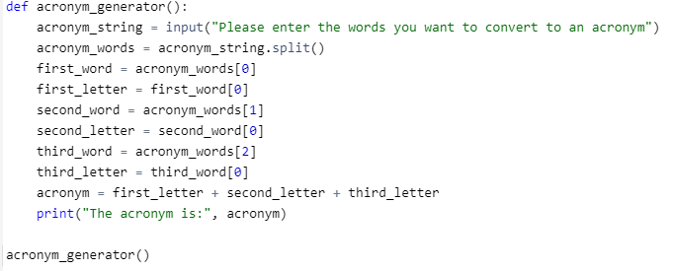

Therefore, when we run the program, we get the desired output:

